**Dungeon Generator Index**

Index **0**: doorway_wide_02.001



Size: 1600 X ??? X 800 (?)

Index **1**: doorway_wide_03.001



Size: 1600 X ??? X 800 (?)

Index **2**: doorway_wide_01.001



Size: 1600 X ??? X 800 (?)

Index **3**: 4way_extrawide_01

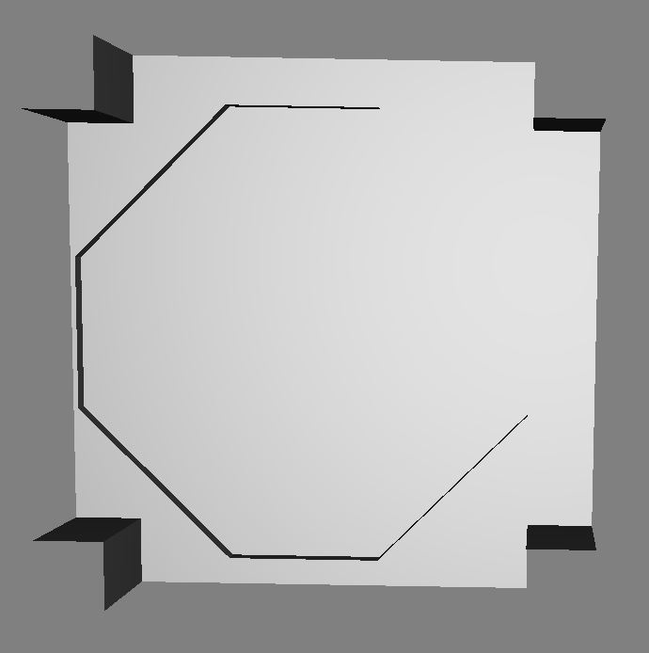

Size: 1600 X 1600 X 800 (?)

Index **4**: 3way*_*extrawide_01

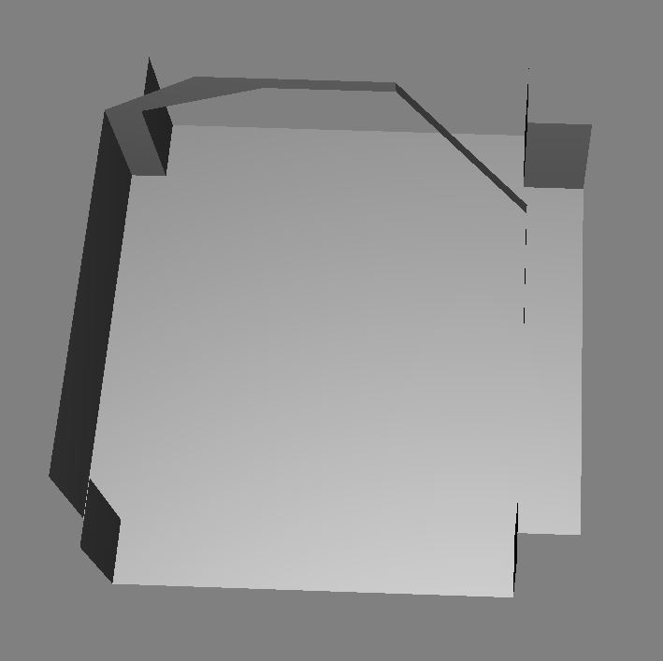

Size: 1600 X 1600 X 800 (?)

Index **5**: 2way*_*extrawide_01

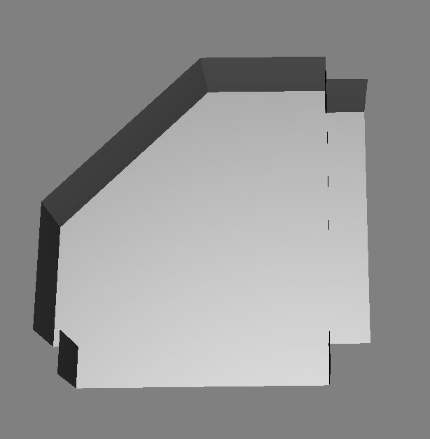

Size: 1600 X 1600 X 800 (?)

Index **6**: 1way*_*extrawide_01



Size: 1600 X 1600 X 800 (?)

Index **7**: Wall_L_01

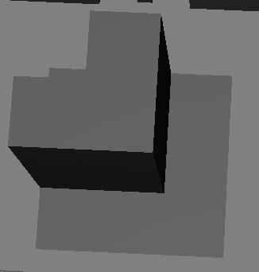

Size: 400 X 400 X 800 (?)

Index **8**: Steps_L_Inner_01

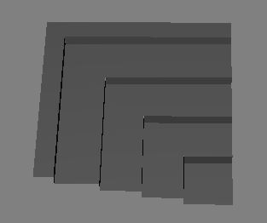

Size: 400 X 400 X ???

Index **9**: Steps_L_Outer_01

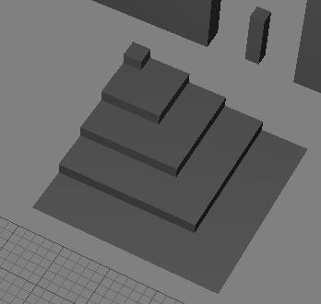

Size: 400 X 400 X ???

Index **10**: Floor_sunkenwall_01

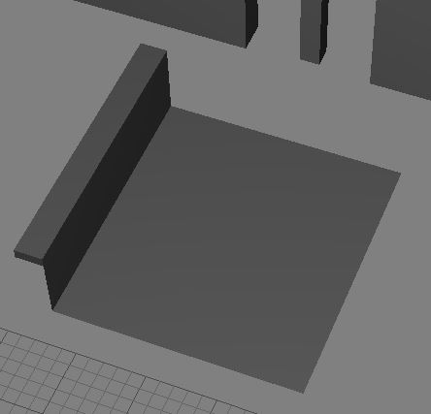

Size: 400 X 400 X ???

Index **11**: Floor_2x2



Size: 400 X 400 X ???

Index **12**: Steps_L_Inner_Curved_01

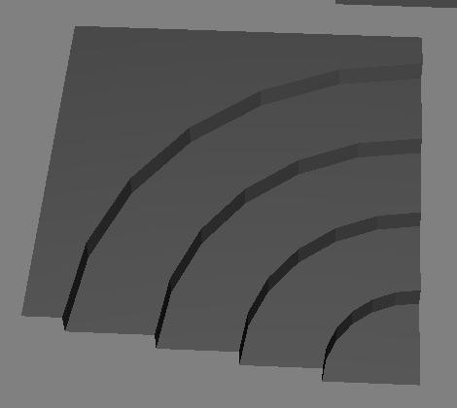

Size: 400 X 400 X ???

Index **13**: Steps_L_Outer_Curved01

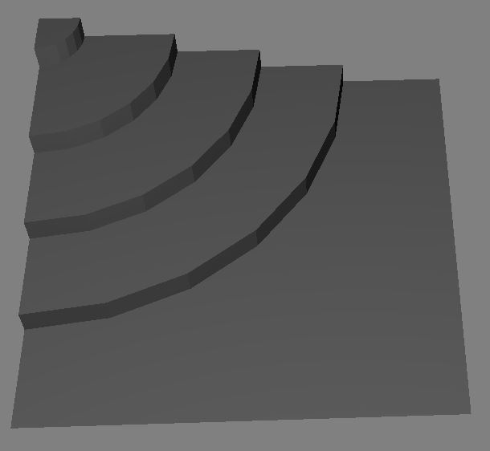

Size: 400 X 400 X ???

Index **14**: Steps_01

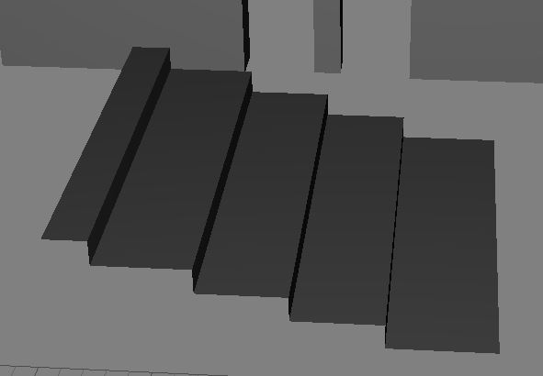

Size: 400 X 400 X ???

Index **15**: Column_Large_01

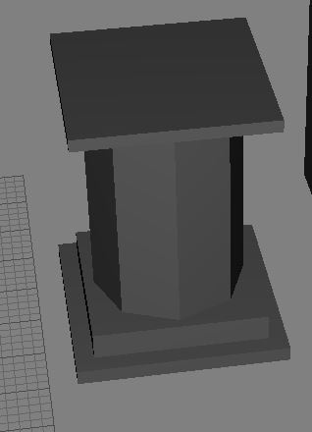

Size: 400 X 400 X ???

Index **16**: Floor_sunkenwall_L_Curved_01

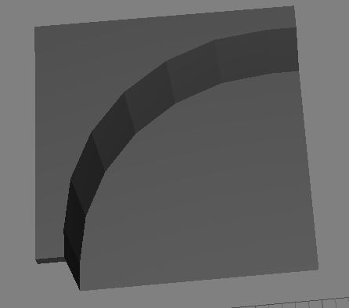

Size: 400 X 400 X ???

Index **17**: 1way_wide_01

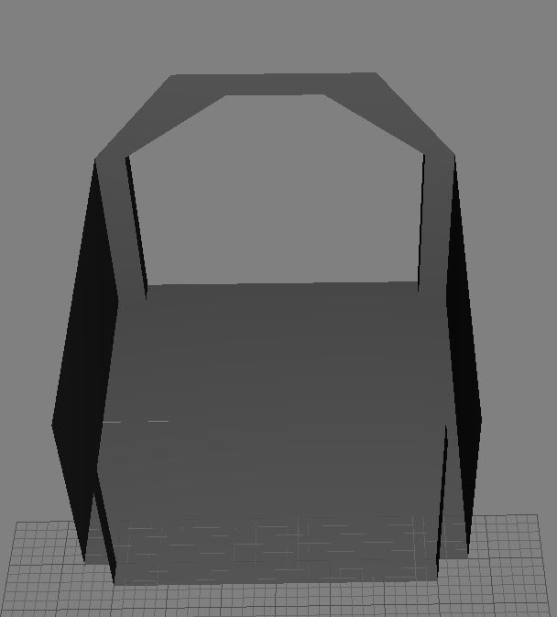

Size: 800 X 800 X 800 (?)

Index **18**: 1way_Stairs_Wide_01

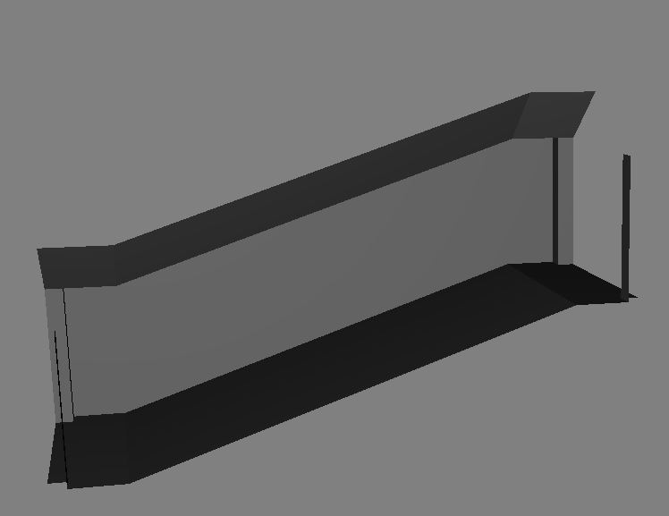

Size: 800 X 1600 X 800(?) + 400(DOWN)

Index **19**: column_small

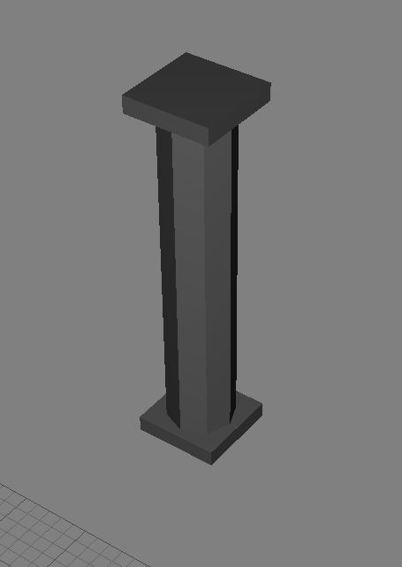

Size: 100? X 100? X 400?

Index **20**: Floor_Sunkenwall_L_01

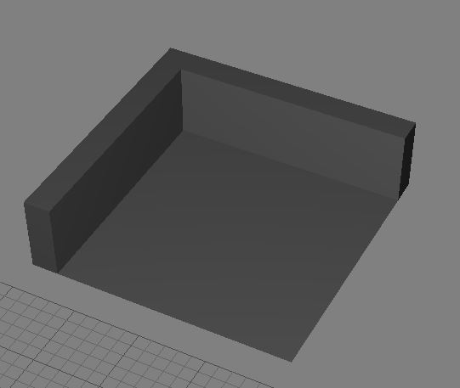

Size: 400 X 400 X ???

Index **21**: Wall_L_Curved_01

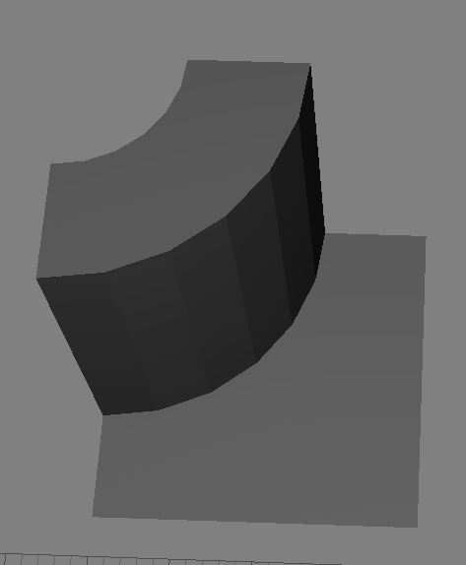

Size: 400 X 400 X ???

Index **22**: Wall_End_01

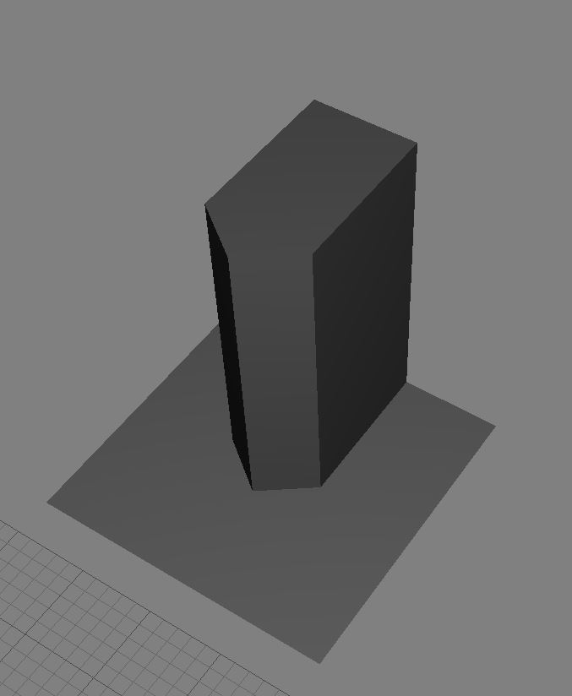

Size: 400 X 400 X ???

Index **23**: Wall_01

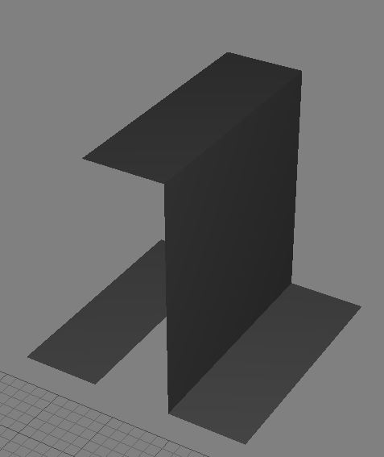

Size: 400 X 400 X ???

Index **24**: Doorway_narrow_01

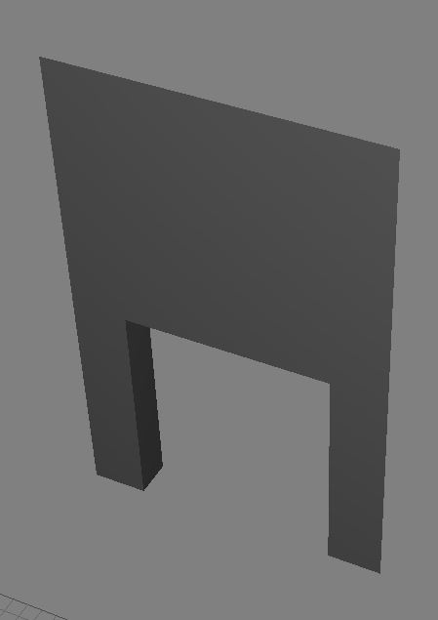

Size: 400 X ??? X 800 (?)

Index **25**: doorway_wide_01

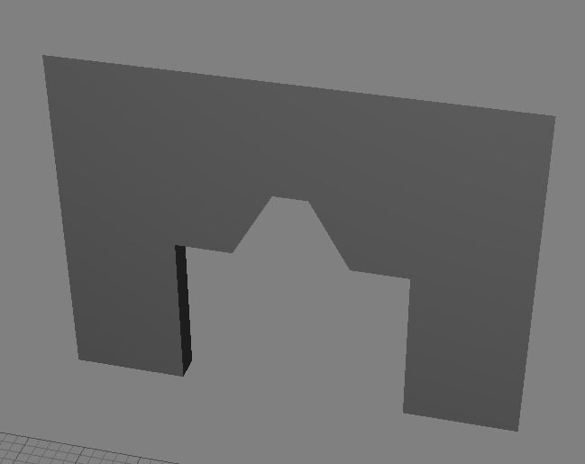

Size: 800 X ??? X 800 (?)

Index **26**: doorway_wide_03

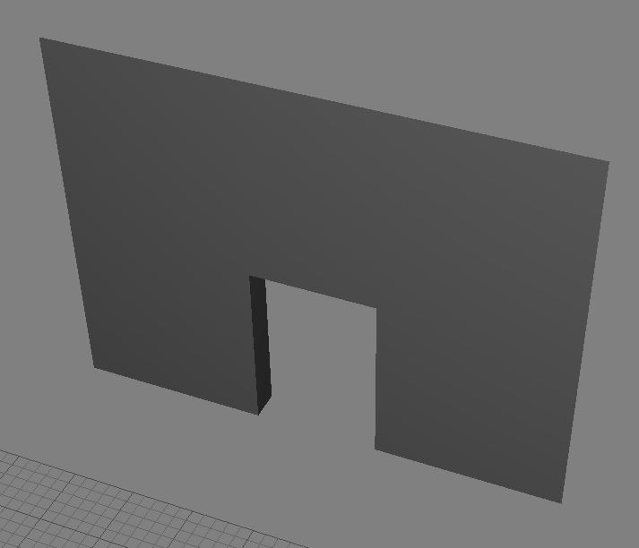

Size: 800 X ??? X 800 (?)

Index **27**: doorway_narrow_03

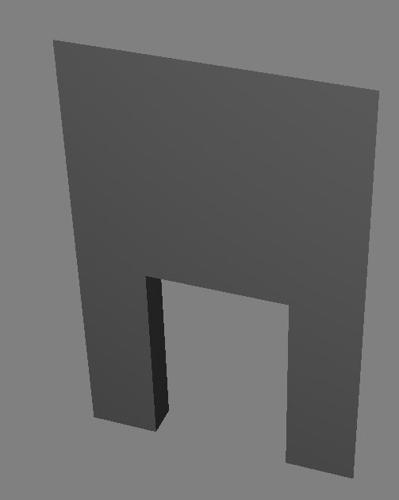

Size: 400 X ??? X 800 (?)

Index **28**: Doorway_narrow_02

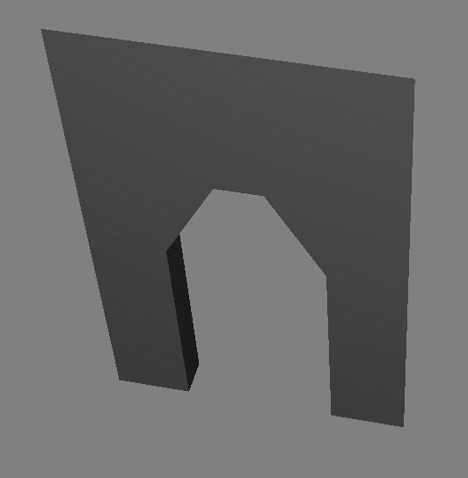

Size: 400 X ??? X 800 (?)

Index **29**: doorway_wide_02

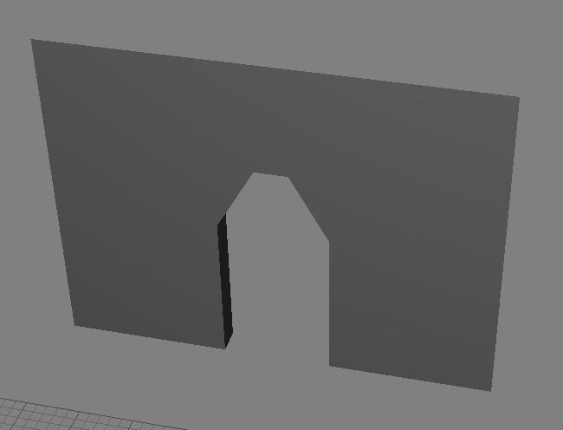

Size: 800 X ??? X 800 (?)

Index **30**: 2way_wide_01

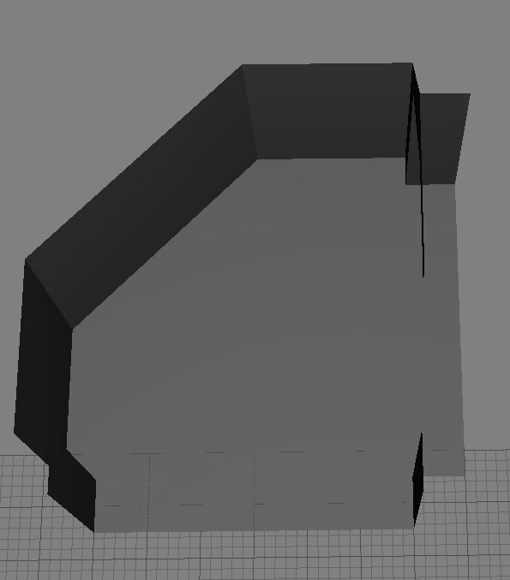

Size: 800 X 800 X 800 (?)

Index **31**: 3way_wide_01

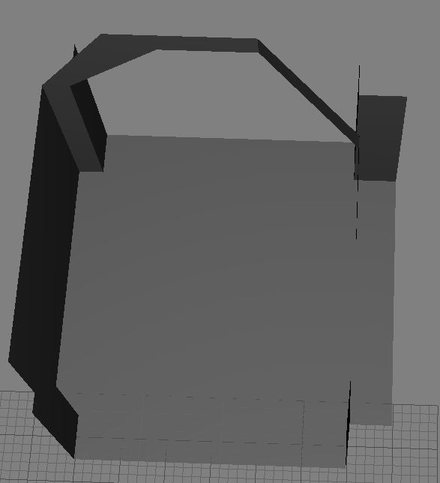

Size: 800 X 800 X 800 (?)

Index **32**: 4way_wide_01

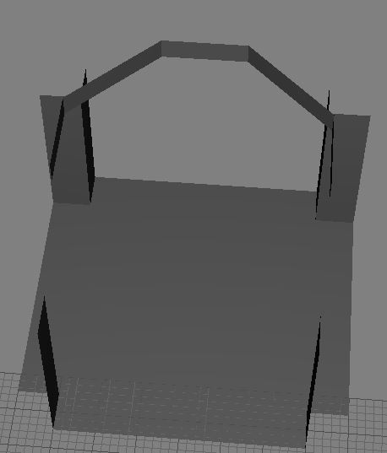

Size: 800 X 800 X 800 (?)

Index **33**: 4way_narrow_01

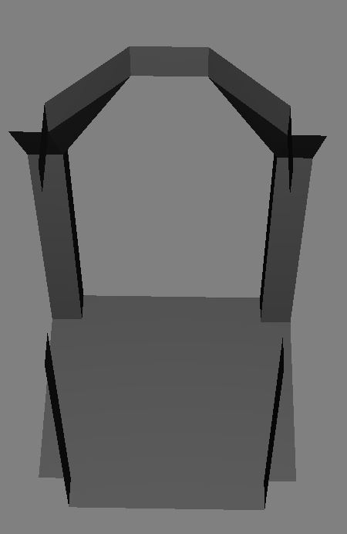

Size: 400 X 400 X 800 (?)

Index **34**: 3way_narrow_01

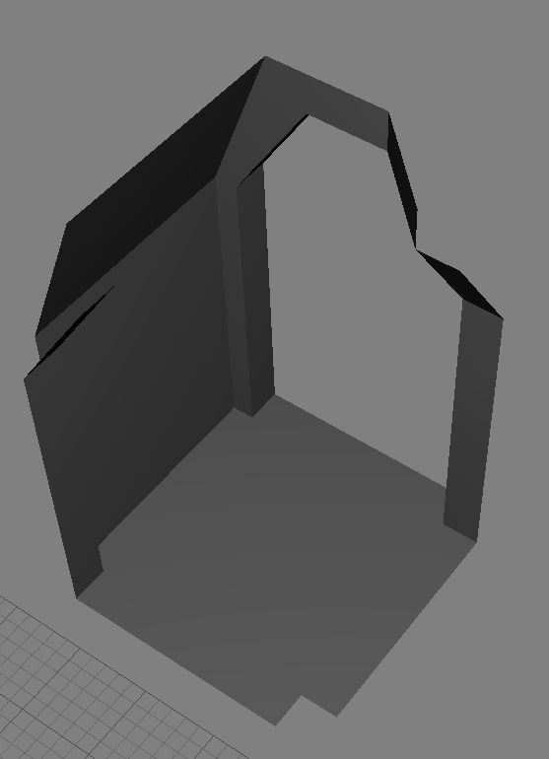

Size: 400 X 400 X 800 (?)

Index **35**: 1way_stairs_Narrow_01

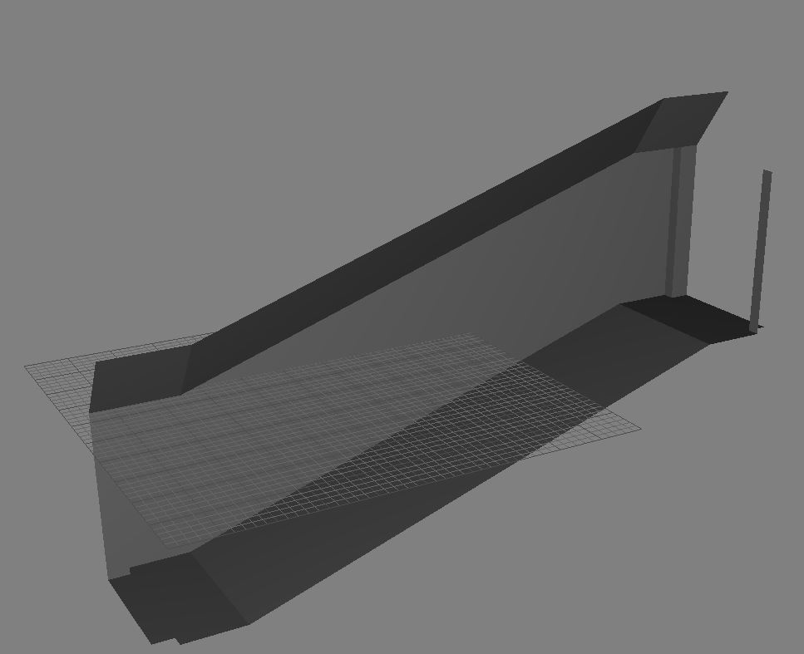

Size: 400 X 1600 X 800 (?) + 400(Down)

Index **36**: 1way. 01

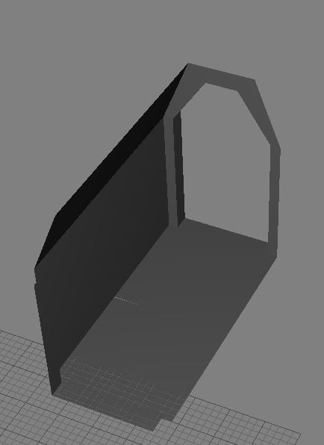

Size: 400 X 800 X 800 (?)

Index **37**: 2way_narrow_01

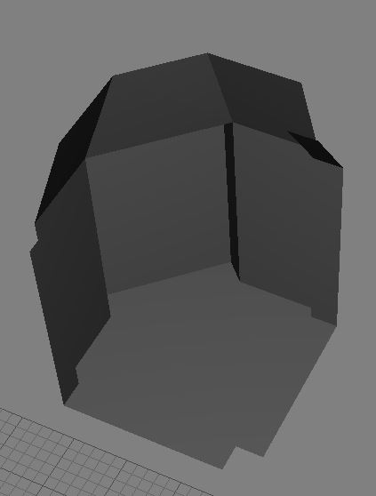

Size: 400 X 400 X 800 (?)